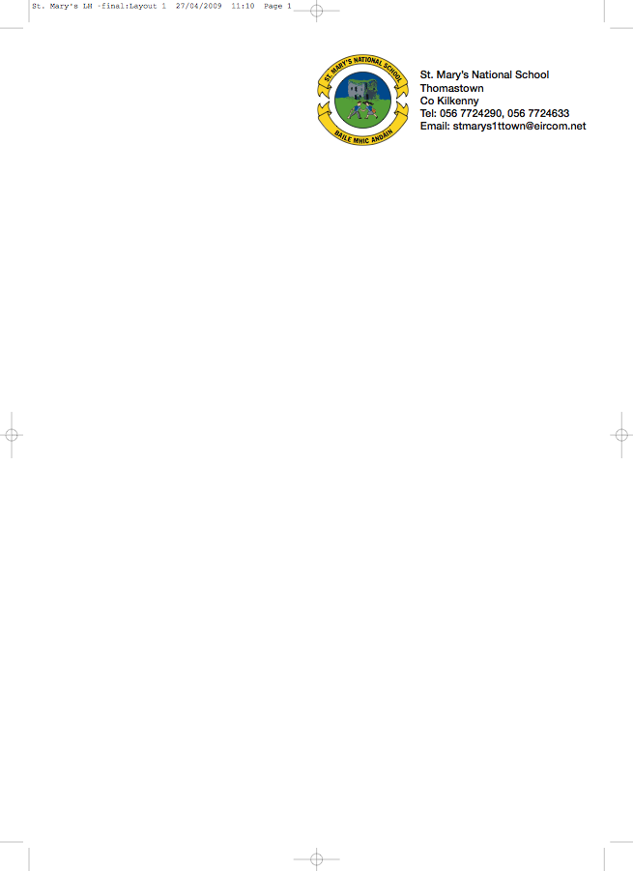

Third Class - BOOKLIST 2017/’18

Class Teacher: Margaret Murphy

GAEILGE (1) Béal Beo 3 (Edco)
(2) Litrigh É Linn 3 (Edco)

ENGLISH (1) Word Wise 3 (CJ Fallon)
(2) Spellbound C (Folens)
(3) Just Write 4A (EdCo)

MATHS (1) Busy at Maths 3 –CJ Fallon
(2) Busy at Maths Shadow Book 3
(3) Brain Teasers 3 (CJ Fallon)
(4) Fallons Table Book (only)

COPIES 10 x 120 page copies
Fallons Homework Journal
1 x A 4 Display Book (60 pockets)

Please put the child’s name on outside cover of all books & copies

- €30 to cover 1. Photocopying 2. Pupil Insurance (24hr cover) 3. Art & Craft

- €20 for renting the following books:

- Get Set
- Earthlink 3rd (Class Book)
- Grow in Love third class Primary 5
- Novels: Tom’s Sausage Lion & Stanley

To avail of A & B above please put €50 in an envelope with your child’s name on it and give it to the teacher in September.

All children must have: *Recorder (available through the school) *2 HB Pencils, red pen, rubber, ruler & pencil sharpner *small box of colouring pencils *Pritt Stick.

No Wheelie Bags
All school stationary available from Liam Reddy’s Shop

See overleaf for uniform details.

